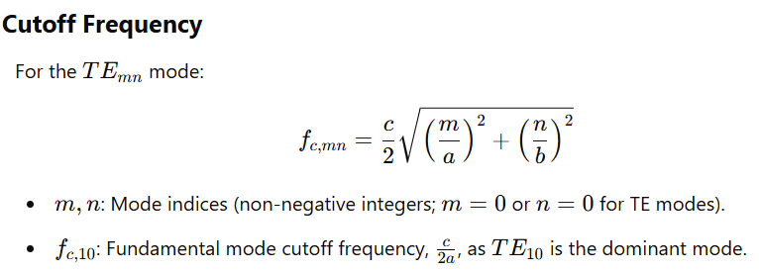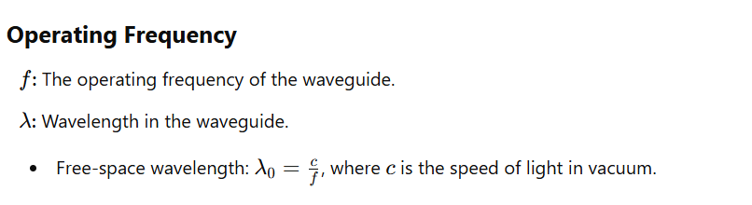
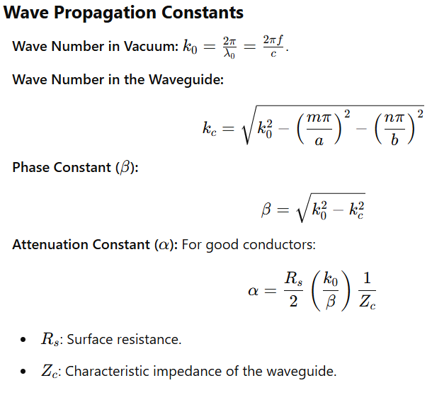
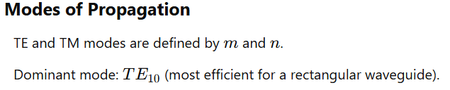
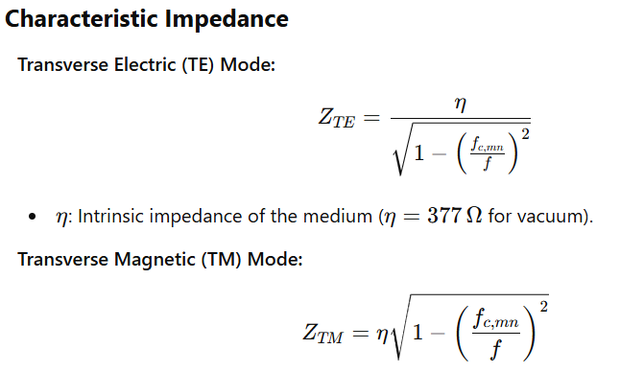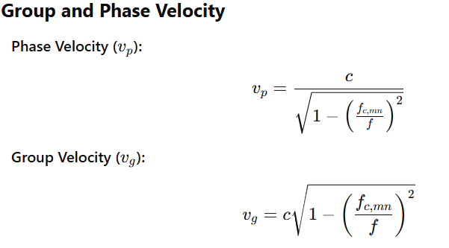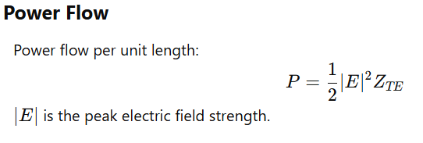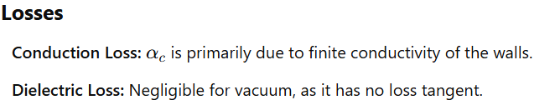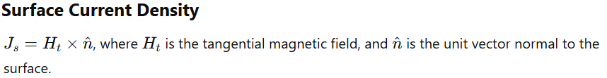

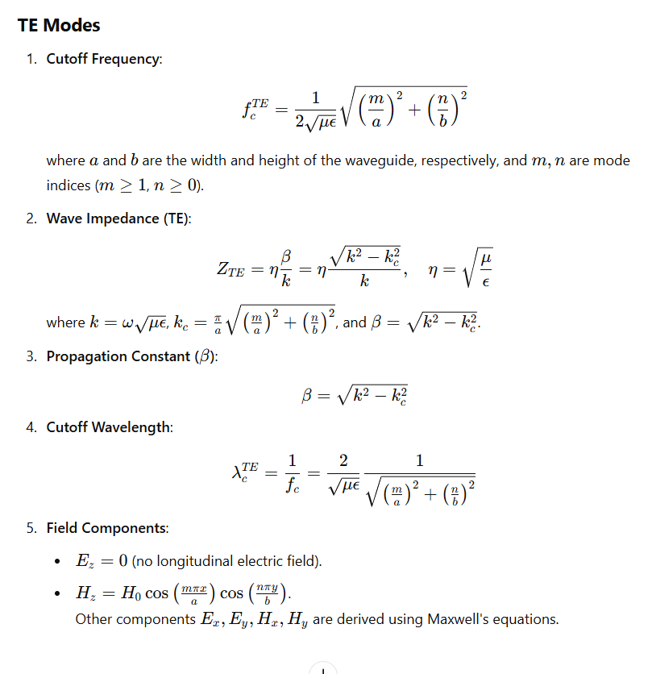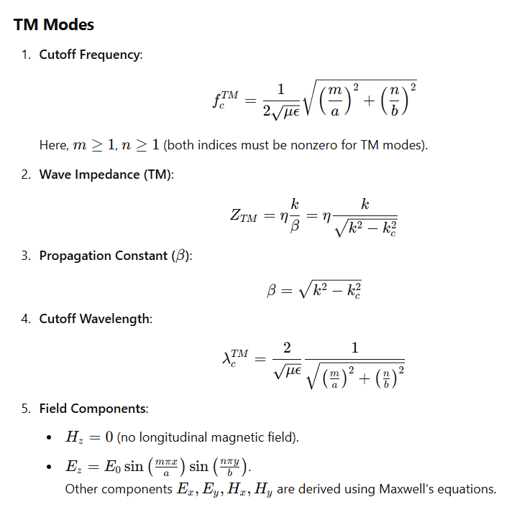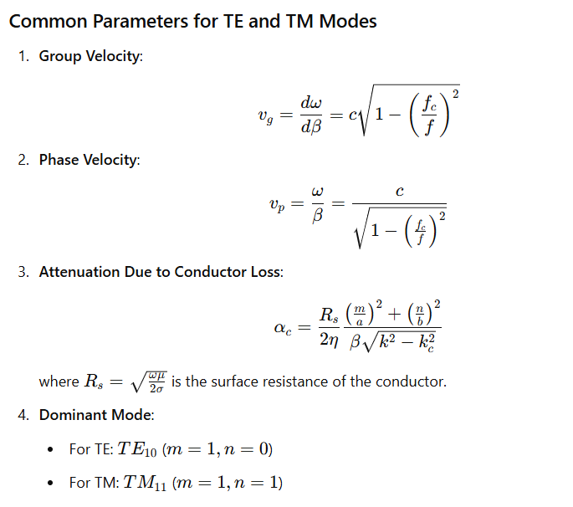
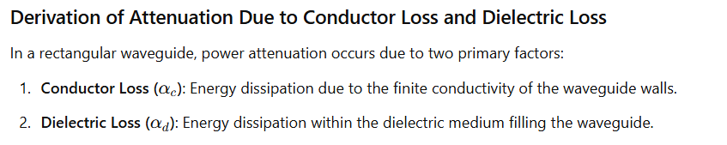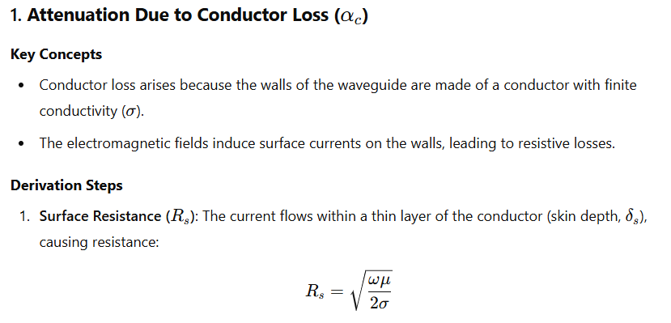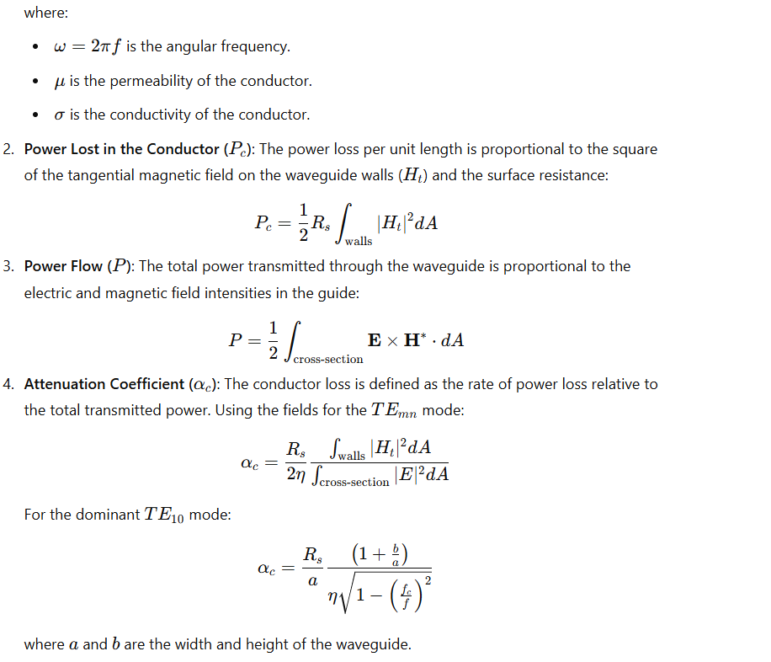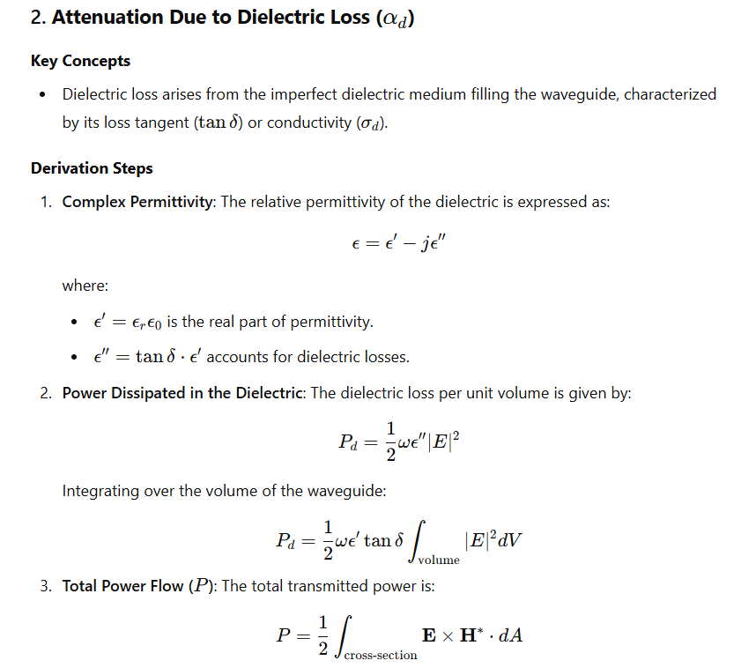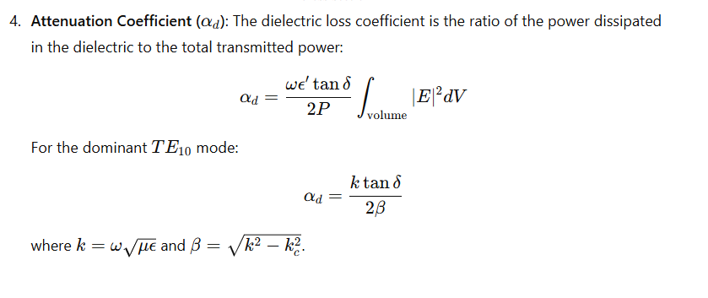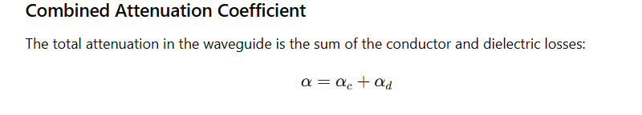
Circular wave guide
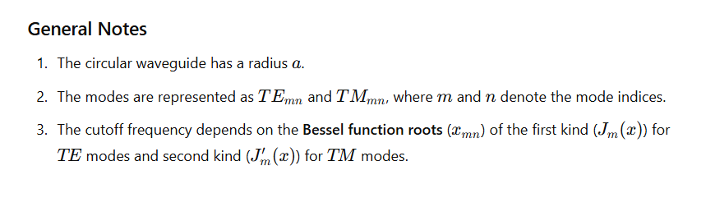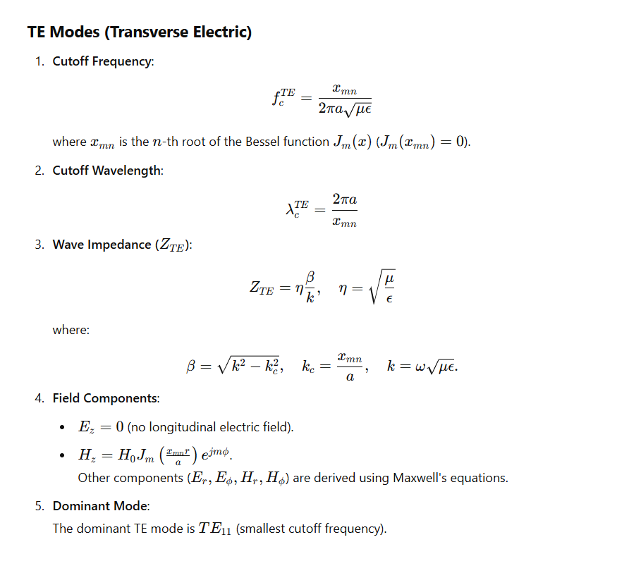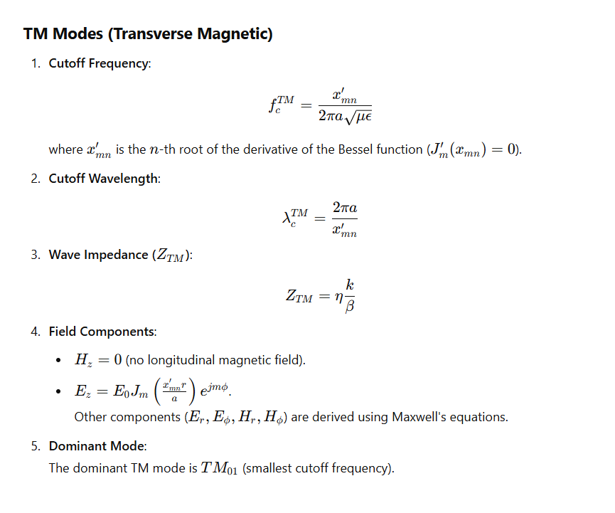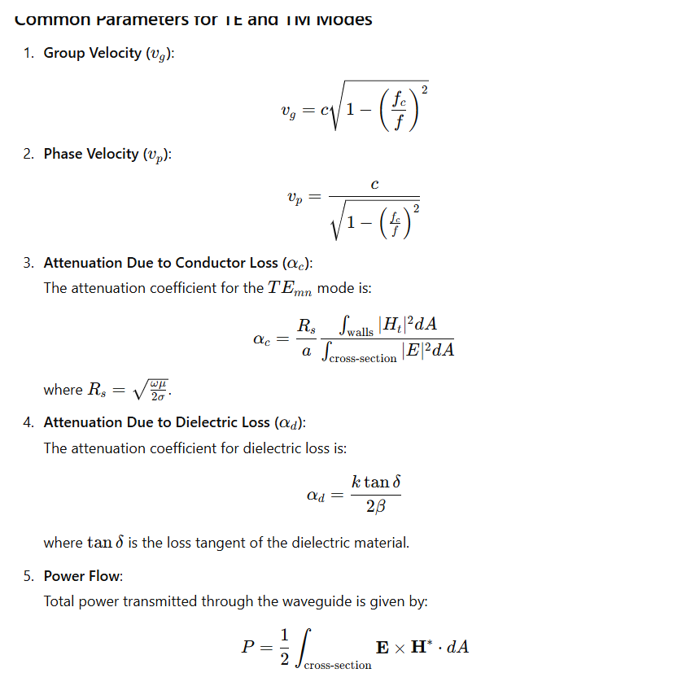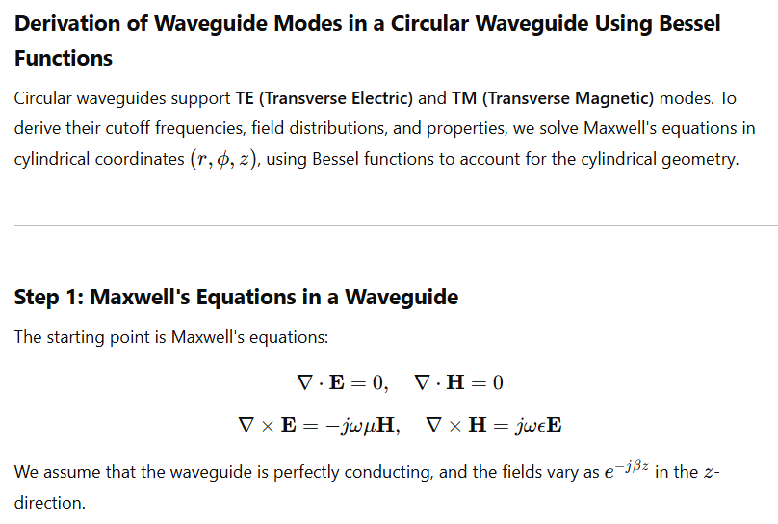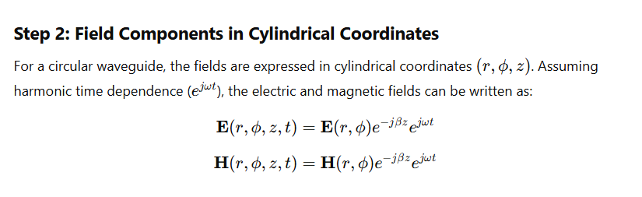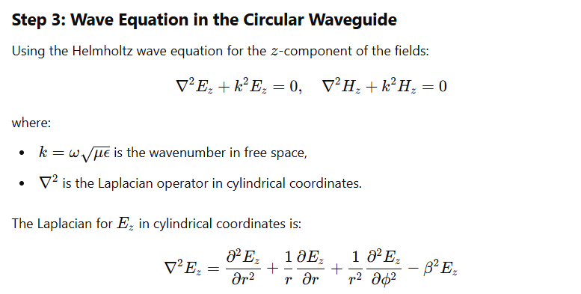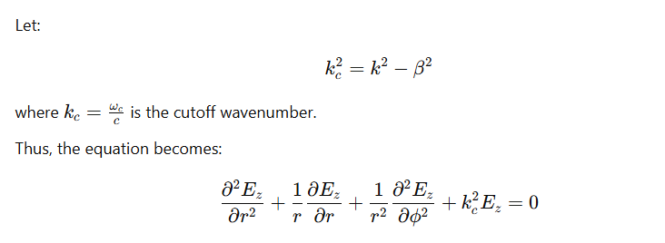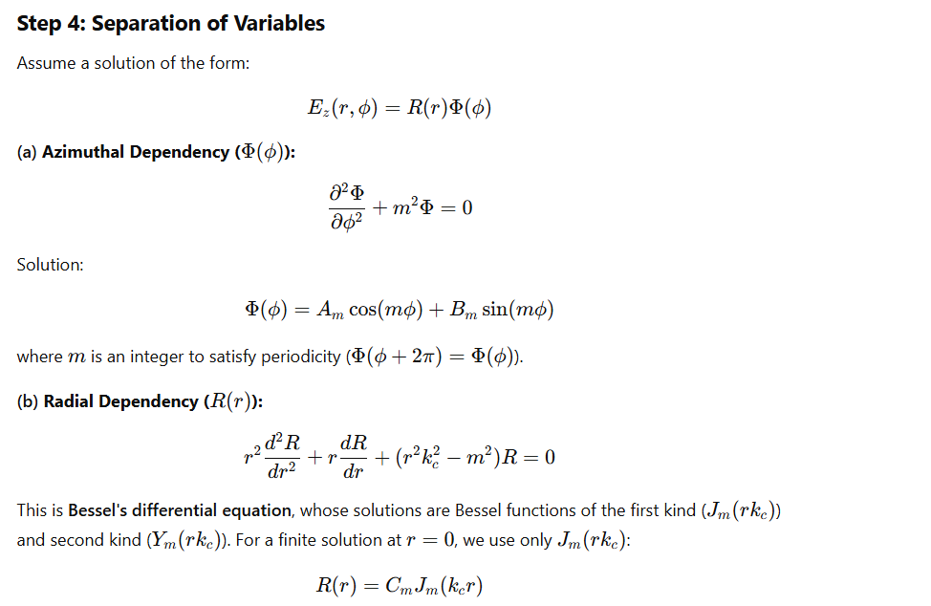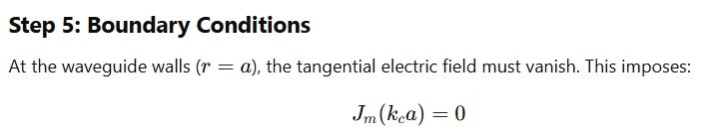
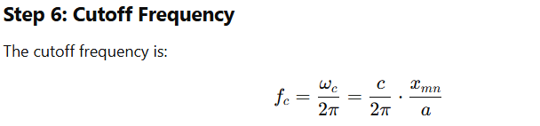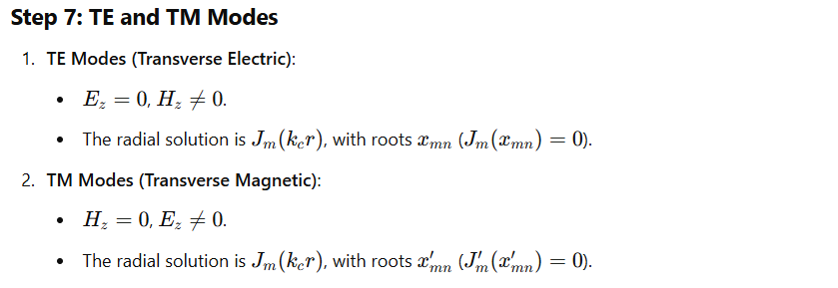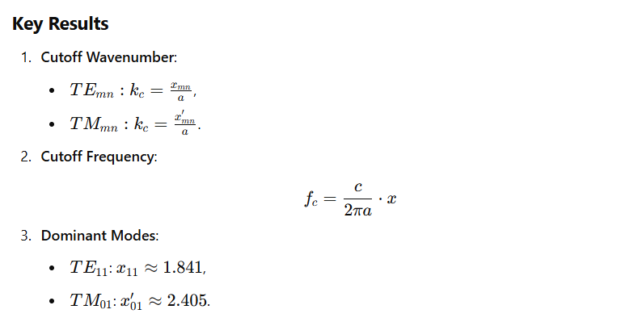

Ferrites in details
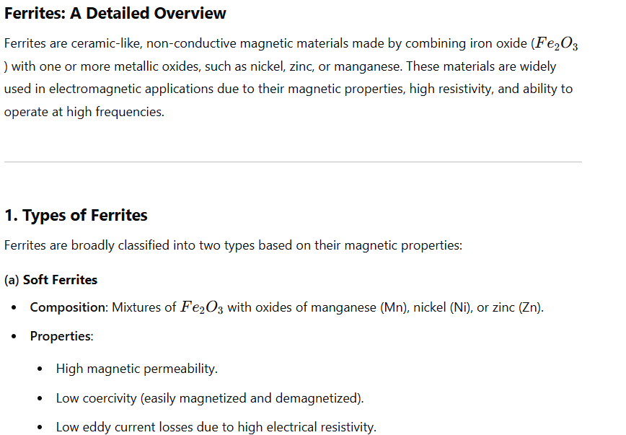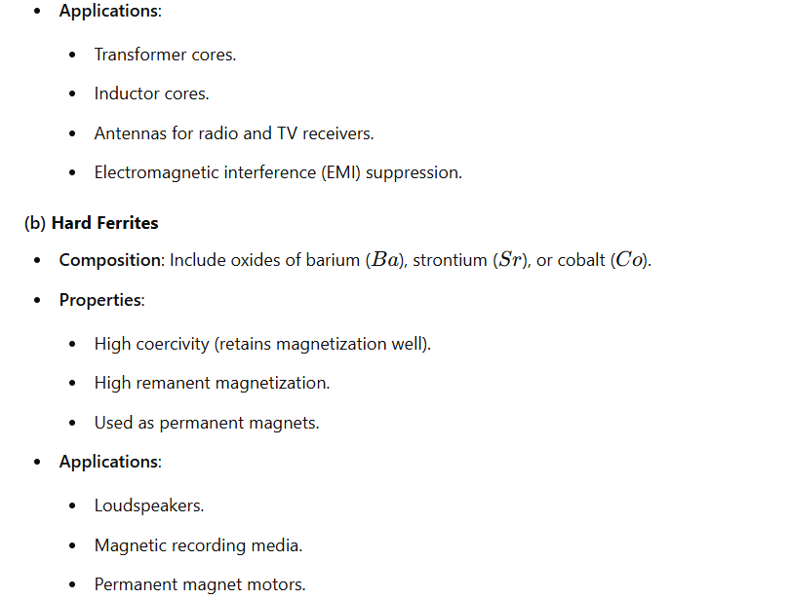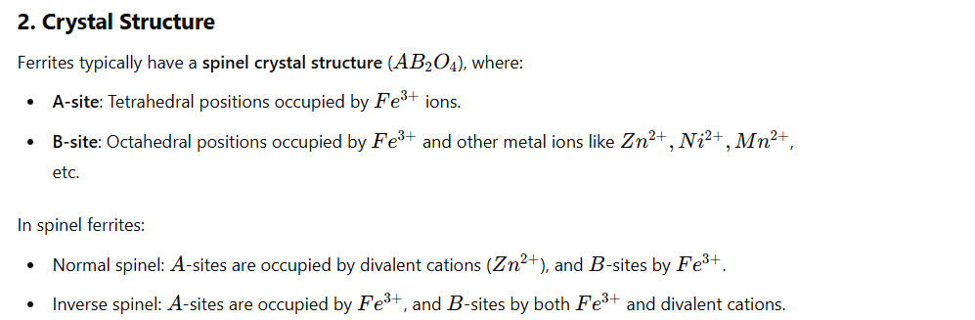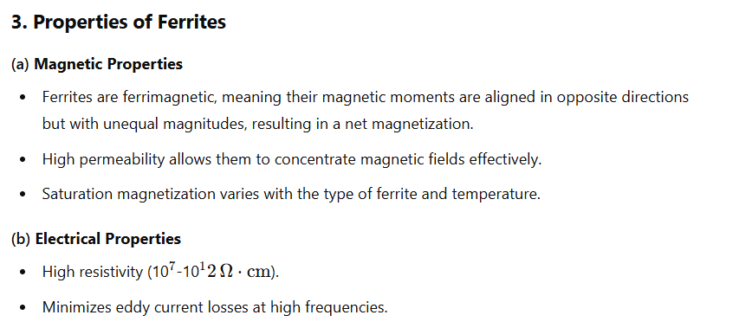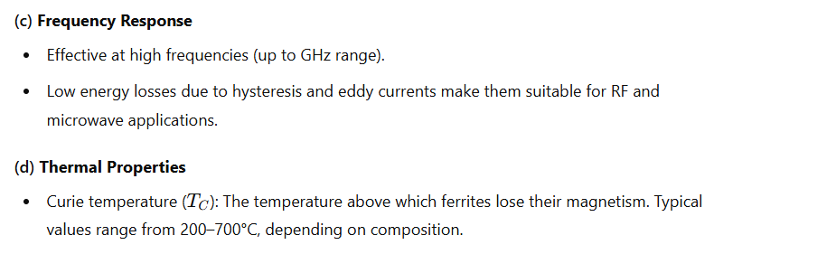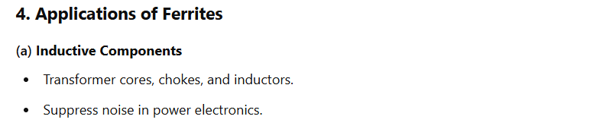
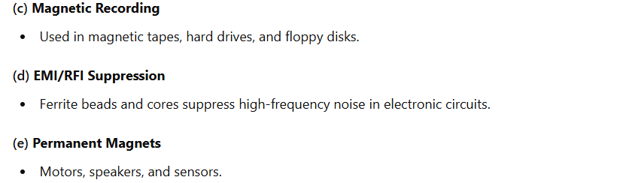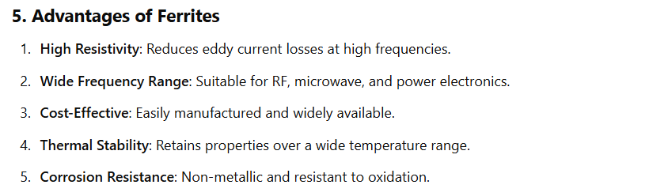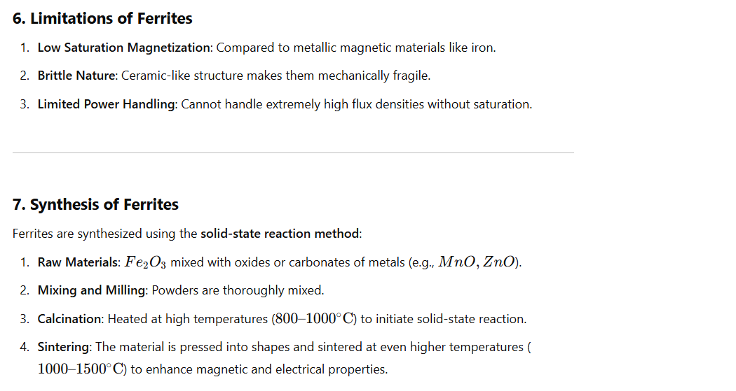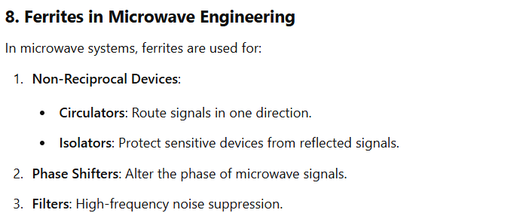
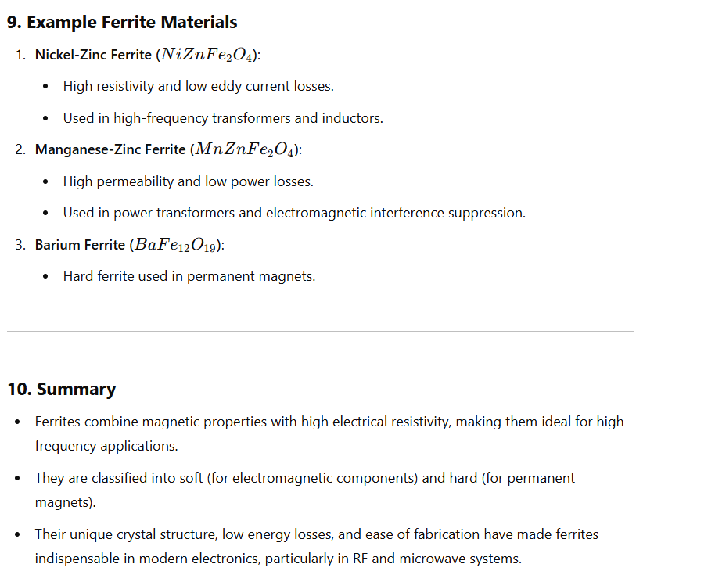
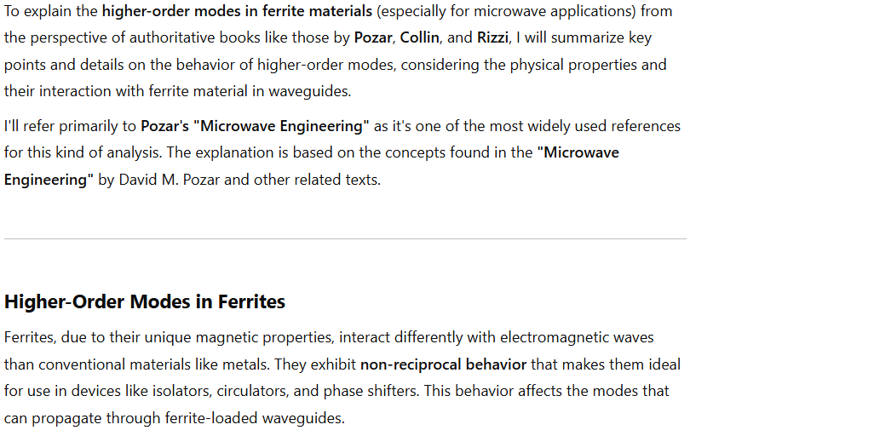

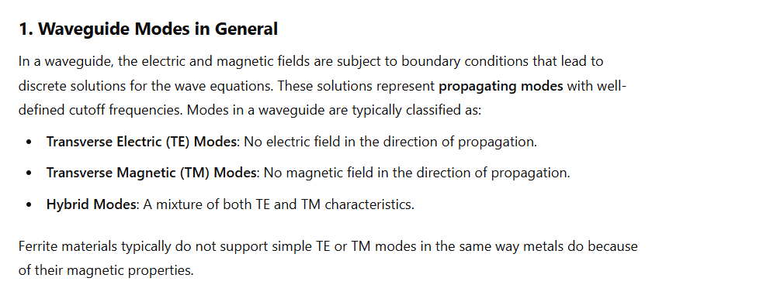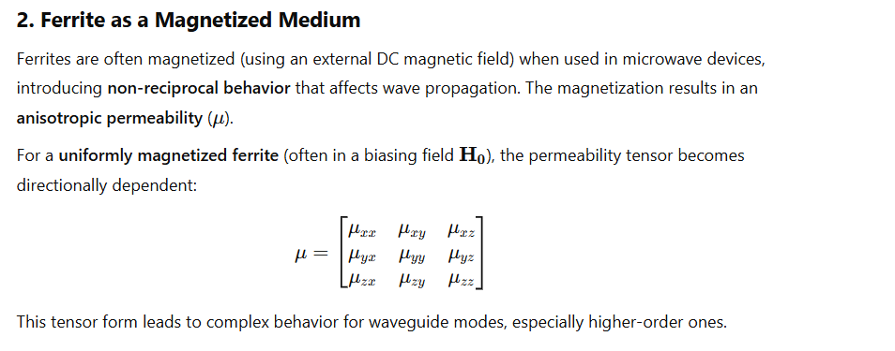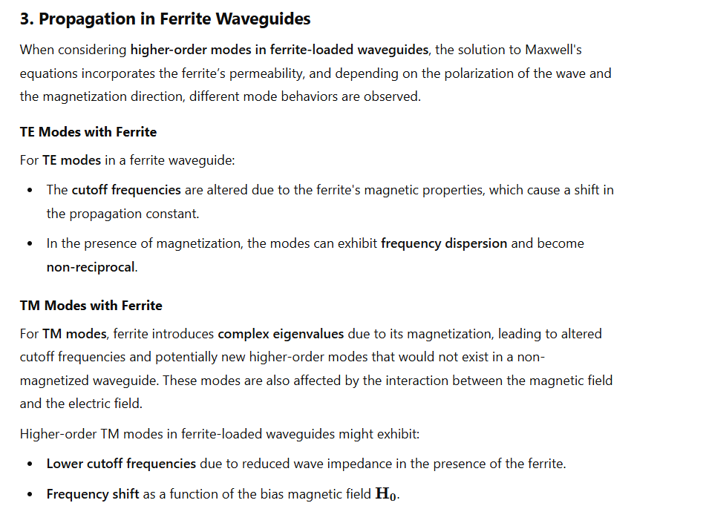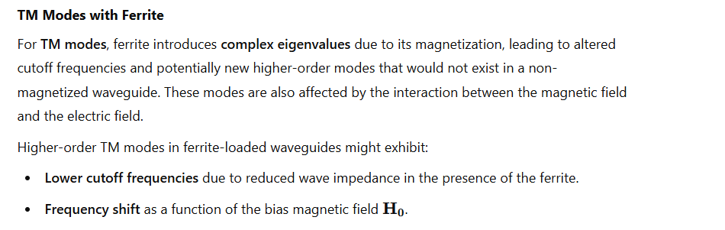
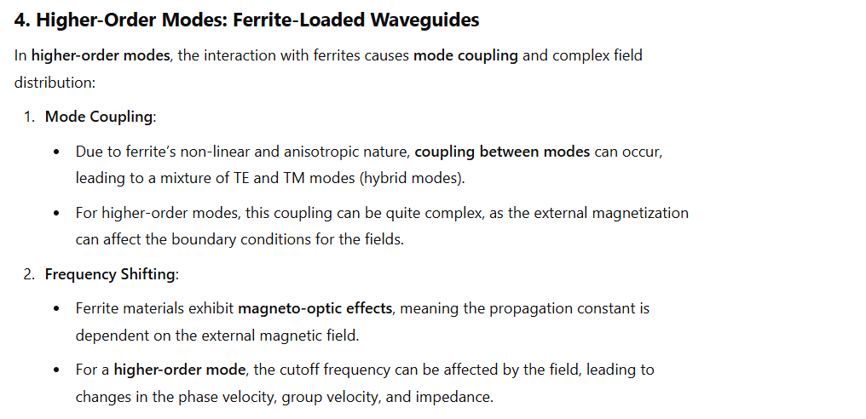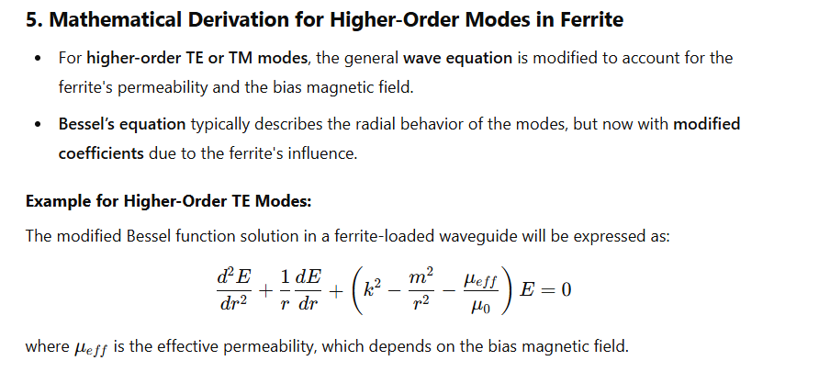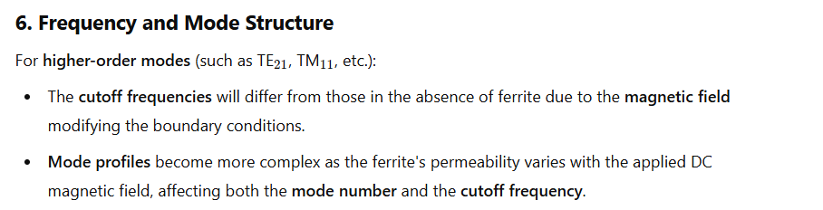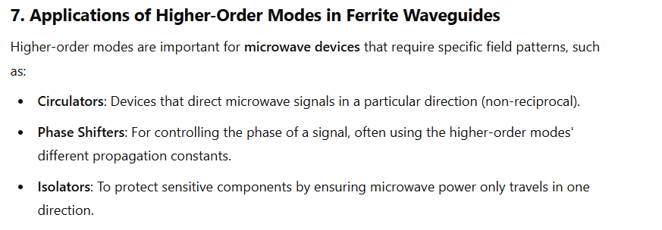
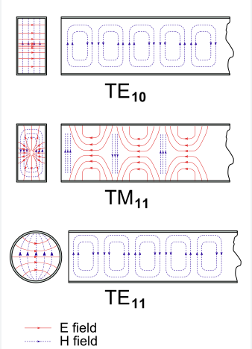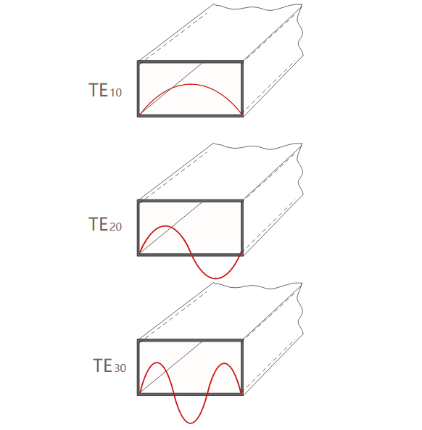
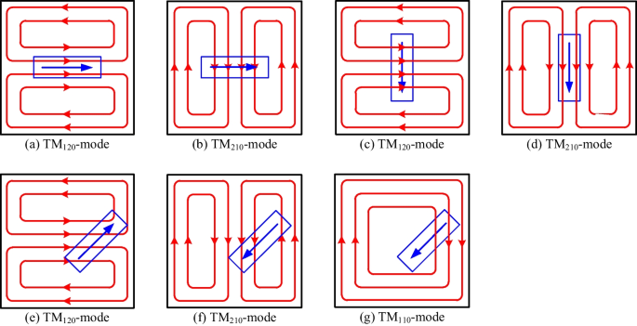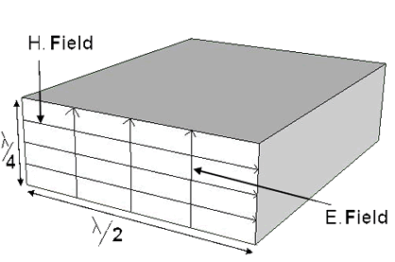TE 10
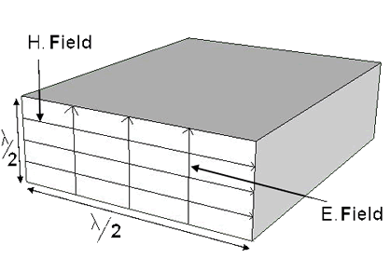TE 11
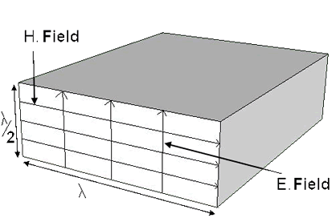TE 20
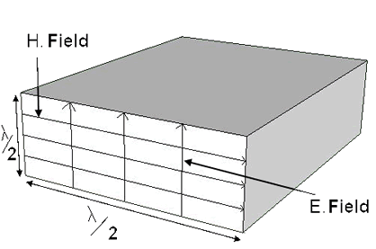TE 01TM 11TM 21
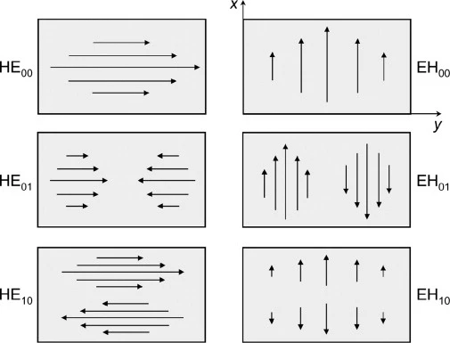

HE Modes (Hybrid Electric Modes):
HE modes are hybrid modes where the dominant field component is the electric field (E), which is primarily transverse to the direction of propagation. These modes typically have a relatively stronger E-field component compared to the H-field component. HE modes are often designated with two subscripts, such as HE1, HE2, etc., indicating the order of the mode.

EH Modes (Hybrid Magnetic Modes):
EH modes are hybrid modes where the dominant field component is the magnetic field (H), which is primarily transverse to the direction of propagation. These modes have a stronger H-field component compared to the E-field component. EH modes are also designated with two subscripts, such as EH1, EH2, etc., indicating the order of the mode.

Mixed-Mode:
Mixed-mode hybrid waveguide modes are those where both the electric and magnetic field components are significant and contribute to the mode's characteristics. In these modes, the E and H fields are oriented in complex patterns that can vary depending on the specific mode and the geometry of the waveguide.

Higher-Order Hybrid Modes:
Both HE and EH modes can have higher-order versions (e.g., HE11, EH21) that correspond to different field distributions and higher propagation modes within the waveguide structure. These modes have additional nodal planes and antinodal planes for the electric and magnetic fields.

Hybrid Plasmonic Modes
In some cases, hybrid modes can also occur in plasmonic waveguides, where the waveguide structure involves interactions with surface plasmon polaritons (SPPs). These modes combine the characteristics of plasmonic modes and traditional waveguide modes.

Tunneling Hybrid Modes
Tunneling hybrid modes are a specific type of hybrid mode that can occur in waveguides with very thin dielectric layers. These modes are characterized by their ability to "tunnel" through the dielectric barrier, allowing for efficient energy transfer across the barrier.

Importance of Waveguide Modes in Signal Propagation
Understanding and utilizing waveguide modes are essential for several reasons:

Signal Integrity
Waveguide modes enable the controlled and guided propagation of signals, reducing the chances of signal distortion or loss. This is particularly critical in high-frequency applications where signal fidelity is paramount.

Minimizing Interference
By selecting the appropriate waveguide mode, it is possible to minimize interference from external sources. TE and TM modes, for instance, can effectively isolate signals from unwanted electrical or magnetic influences.

Signal Directionality
Waveguide modes allow for precise control over the direction in which signals propagate. This directional control is crucial in applications like antennas and satellite communication, where signal timing is essential.

Transitioning to Efficient Signal Propagation
In conclusion, waveguide modes play a pivotal role in the efficient propagation of signals in various communication and transmission systems. Their ability to guide electromagnetic waves while minimizing interference is invaluable in ensuring reliable and high-quality signal transmission.

